THE FIRST PhD GRADUATE OF ERAMUS + “DSinGIS” PROJECT

On 2nd June 2021 project manager Mamanbek REIMOV defended his doctoral (PhD) dissertation on technical science on the topic “Geoinformation analysis and mapping of ecosystem and their services in the protected natural areas of the Aral Sea region”, which was registered at the Supreme Attestation Commission at the Cabinet of Ministers of the Republic of Uzbekistan in the framework of ERASMUS+ 585718-EPP-1-2017-1-HU-EPPKA2-CBHE-JP DSinGIS “Doctoral Studies in Geoinformation Sciences” project. The doctoral dissertation has been prepared at the Tashkent Institute of Irrigation and Agricultural Mechanization Engineers and supervised by Professor. Alexander FEHER from Slovak University of Agriculture in Nitra.
Need to state that, in the list of scientific Council of thee specialization “11.00.07 “Geoinformatics” there were two professors: Prof. Bela MARKUS and Dr. Lorant FOLDVARY from Obuda University, Hungary became a member.
The scientific novelty of the research work consists in the following:
the methods of interpretation of satellite images was improved, taking into account the spectral indexes of moisture, desertification and salinity of the soil surface for three decades, and for the first time desertification and transformation of ecosystems of protected natural areas of the Southern Aral sea region were determined.
in addition to the normalized vegetation index, for the first time a landscape-ecological map of a scale of 1: 250 000 was created for the complex (landscape) reserve "Saigachiy", taking into account the spectral indices of humidity and salinity of surfaces;
a method for mapping ecosystem services has been developed, taking into account the location of regional ecosystem services based on the zoning of natural areas adjacent to agricultural landscapes, in addition to the protected, buffer, economic and agricultural zone;
for the first time, a map of ecosystem services of the Lower Amudarya State Biosphere Reserve was developed on a scale of 1: 500 000, taking into account the supply, regulation, habitat and cultural services of protected areas near agricultural landscape.
Implementation of the research results: Based on the scientific results obtained on the study of the protected natural areas of the Southern Aral Sea region:
using the example of the complex (landscape) reserve "Saigachy", based on the results of geoecological analysis and monitoring, a landscape-ecological map of the region at a scale of 1: 250 000 was introduced into the complex (landscape) reserve "Saigachy" (Reference from the State Committee on Ecology and Environmental Protection of the Republic of Karakalpakstan dated December 4, 2020, 02/18-1-2314). As a result, it became possible to use various spectral indices for geoecological analysis and monitoring of transformation processes in natural ecosystems.
a method for mapping ecosystem services of the Lower Amudarya State Biosphere Reserve was developed, taking into account the peculiarities of protected natural areas close to agricultural landscapes, and a map of ecosystem services at a scale of 1: 500 000 was introduced in the Lower Amudarya State Biosphere Reserve (Reference from the State Committee on Ecology and Protection the environment of the Republic of Karakalpakstan dated December 4, 2020, 02 / 18-1-2314). As a result, it became possible to monitor the state, types, and quantitative indicators of ecosystem services in the Lower Amudarya State Biosphere Reserve.
the method of optimization of the territorial composition of the Lower Amudarya State Biosphere Reserve, taking into account the results of the analysis of ecosystem services, was introduced in the Lower Amudarya State Biosphere Reserve (Certificate of the State Committee on Ecology and Environmental Protection of the Republic of Karakalpakstan dated December 4, 2020, 02 / 18-1-2314). As a result, it became possible to determine the main ecosystem services that can be used as a target task when solving problems of optimizing the spatial structure of protected areas adjacent to agricultural landscapes.

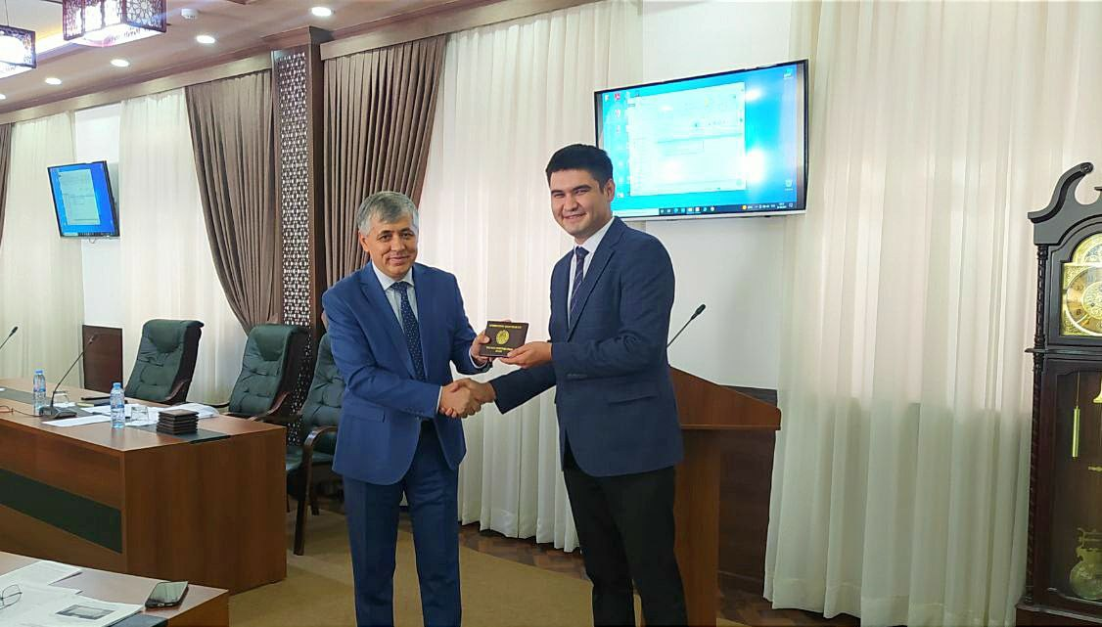
Diploma award ceremony, at TIIAME Scientific Council in September 2021

